Terrigal Parish History Book

Each week we want to encourage as many parishioners as possible to send in a photo with a few lines about it. The photos and short story will be put in the bulletin and /or kept to put in our Terrigal Parish History Book which we are aiming to get ready for December this year, this will coincide with our 20th anniversary of the relocation of the church at this site.
Please send your photos and stories to the Parish Office at starsea@bigpond.net

Catechist Training at Kincumber in 1992 …… by Janette Merrotsy

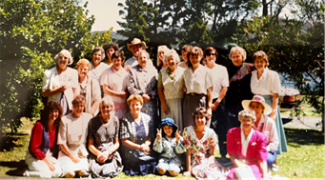

Our catechist training in these days was done over three years in six week blocks. It was a time of building friendships and above all learning how to teach about our faith to the children in our state schools.
In the picture can you find Betty Brown, Janette Merrotsy, Gabrielle Catanzariti, Jack Costa, Sandra Jackson, Brenda Hindmarsh , Maureen Reynolds, Barb Hooper, Gwen Grove and more?

I remember when … supplied by the Parish Office

Each week we want to encourage as many parishioners as possible to send in a photo with a few lines about it. The photos and a comment will be put in the bulletin and /or kept to put in our Terrigal Parish History book which we are aiming to get ready for December this year, this will coincide with our 20th Anniversary of the relocation of the church at this site.

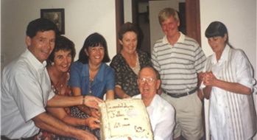

Fr Carol Grew in 1997 celebrating his 43rd
Anniversary of his Ordination with
Ray & Barbara Cooper, Janette Merrotsy,
Brenda & Vic Hindmarsh, Judith Sulter

